Car Parking
Abstract:
In these modern days finding car parking is a big issue in congested cities. There are too many vehicles on the road but not enough parking spaces. One of the biggest problems is when we enter a parking area then we realize that there are no empty parking slots to park our cars. Important time. Another biggest problem is after entering in a big parking area we confused to find the empty parking slot to park our car. Sometimes maybe we all have been facing these two problems that wasted our important time. That’s why we need efficient parking management systems in all parking areas that will provide confusion-free and easy parking.

Components:
Arduino Nano or Arduino Uno
USB Cable for Arduino
IR Sensor
SG90 Servo Motor
9V power supply

Arduino Nano:
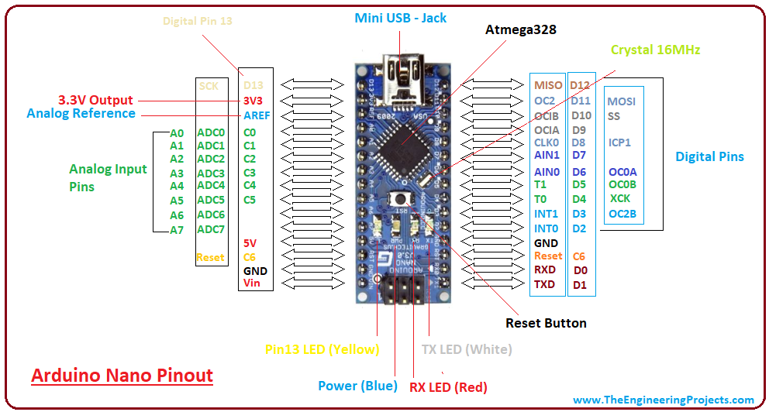

- The Arduino Nano has a compact size and mini USB cable than the Arduino UNO. We can use Nano instead of UNO because both operate on the microcontroller ATmega328p.
- The Arduino UNO is also easily available than Nano. It is considered as the standard board available in the market, which is easy for use for the starters or beginners.
- The Nano is available in PDIP (Plastic Dual - Inline Package), while Arduino UNO is available in TQFP (Plastic Quad Flat Pack).
- The Arduino UNO includes 6 analog pin inputs, 14 digital pins, a USB connector, a power jack, and an ICSP (In-Circuit Serial Programming) header. The Arduino Nano includes an I/O pin set of 14 digital pins and 8 analog pins. It also includes 6 Power pins and 2 Reset pins.

Technical Specifications
The technical specifications of the Arduino Nano board are:
- The operating voltage of the Nano board varies from 5V to 12V.
- The total pins in Nano are 22 Input/Output pins.
- There are 14 digital pins and 8 analog pins.
- There are 6 PWM (Pulse Width Modulation) pins among the 14 digital pins. The 6 PWM pins in Arduino Nano are used to convert the digital signals into the analog signals. The conversion takes place by varying the width of the pulse.
- The crystal oscillator present in Arduino Nano comes with a frequency of 16MHz.
- The Arduino Nano is used in various applications such as Robotics, Control System, Instrumentation, Automations, and Embedded Systems.
- The projects created using Arduino Nano are QR Code Scanner, DIY Arduino Pedometer, etc.
- We can also connect Arduino Nano to the Wifi.
- The functionality of Nano is similar to the Arduino UNO.
- The flexibility and eco-friendly nature of Nano make it a unique choice to create electronic devices and projects with compact size.
I2C LCD:

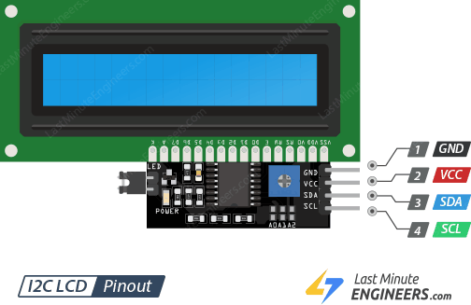
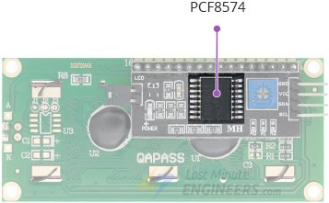

Wiring an I2C LCD Display to an Arduino:
Connecting an I2C LCD is much simpler than connecting a standard LCD. You only need to connect four pins.
Begin by connecting the VCC pin to the Arduino’s 5V output and the GND pin to ground.
Now we are left with the pins that are used for I2C communication. Note that each Arduino board has different I2C pins that must be connected correctly. On Arduino boards with the R3 layout, the SDA (data line) and SCL (clock line) are on the pin headers close to the AREF pin. They are also referred to as A5 (SCL) and A4 (SDA).
IR Sensor:
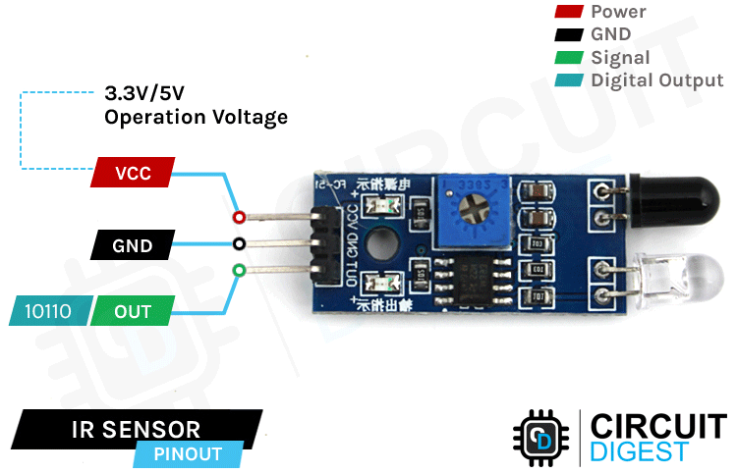
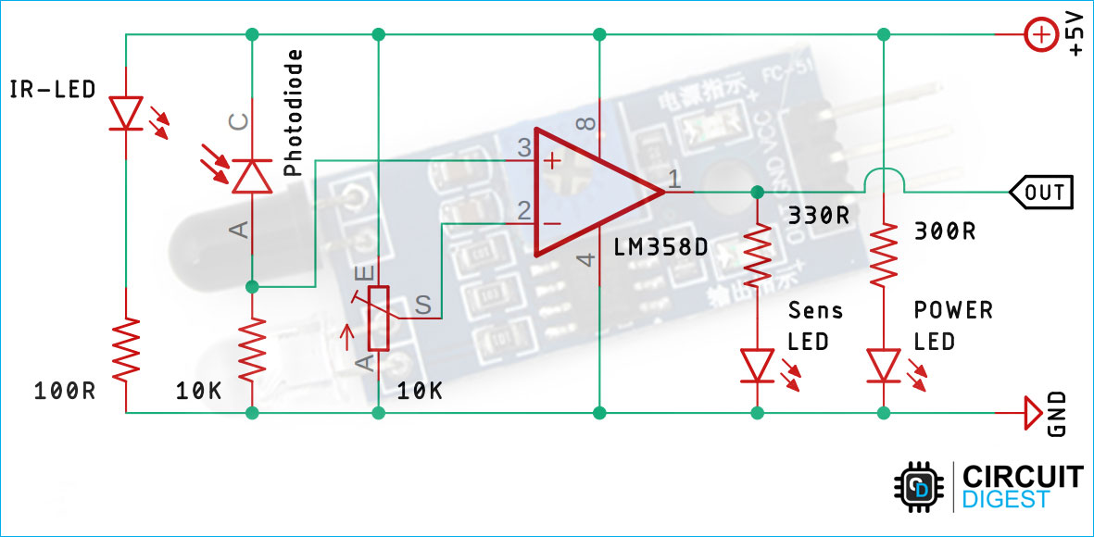

An infrared proximity sensor or IR Sensor is an electronic device that emits infrared lights to sense some aspect of the surroundings and can be employed to detect the motion of an object. As this is a passive sensor, it can only measure infrared radiation. This sensor is very common in the electronic industry and if you’ve ever tried to design an obstacle avoidance robot or any other proximity detection-based system.
The working of the IR sensor module is very simple, it consists of two main components: the first is the IR transmitter section and the second is the IR receiver section. In the transmitter section, IR led is used and in the receiver section, a photodiode is used to receive infrared signal and after some signal processing and conditioning, you will get the output.

Circuit Diagram
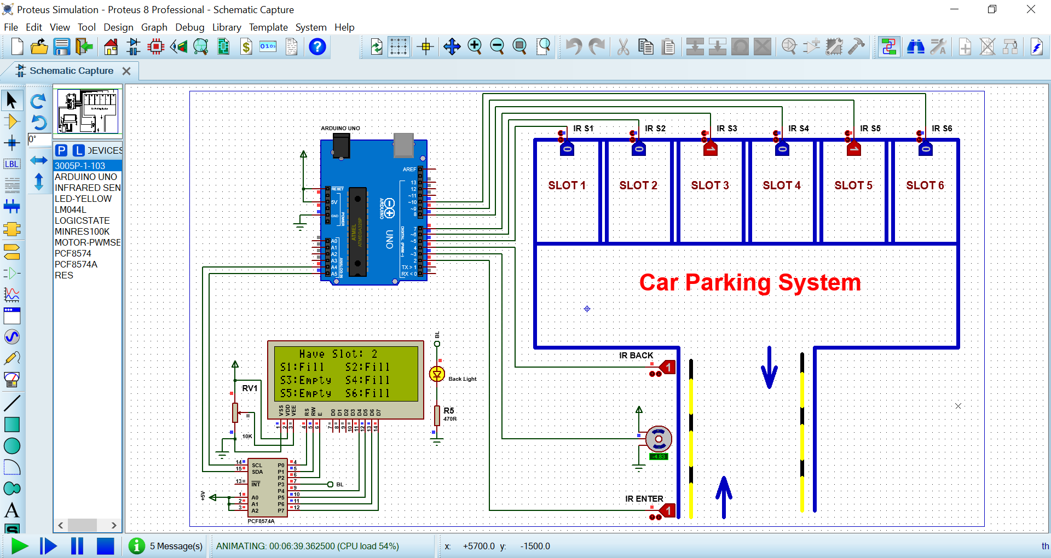
Code:
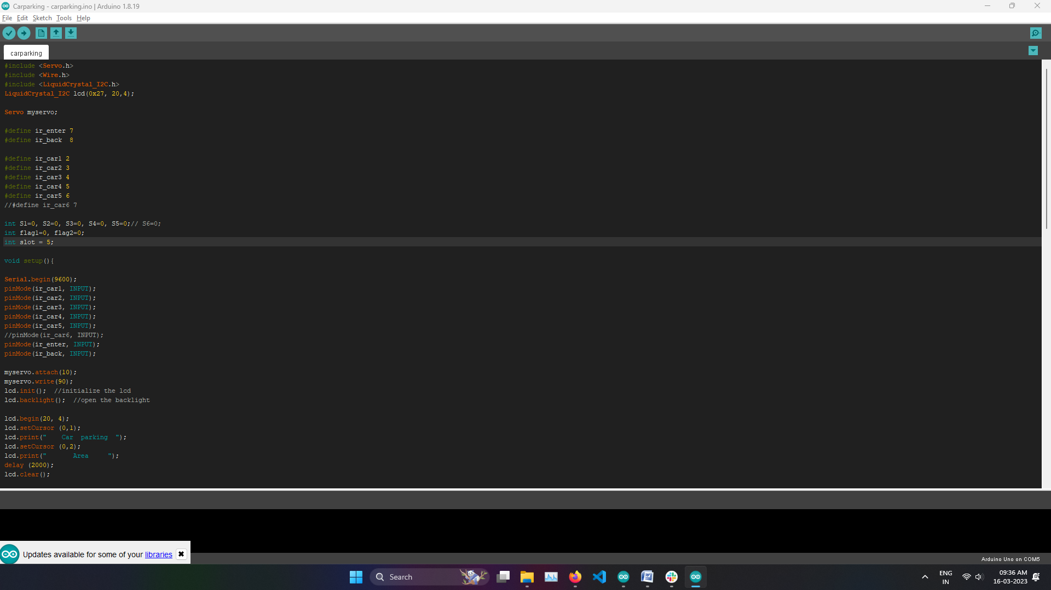


Conclusion:

The parking places are continuously monitored, and the data on the LCD screen is updated on a regular basis. The LCD screen shows the exact location of the parking slot availability status.
Furthermore, the proposed parking system was evaluated utilising a user acceptance test to determine public acceptance of the proposed parking system. The majority of respondents thought the proposed parking system with IR sensor was a wonderful concept and that developing a parking system that can help cars find a vacant parking spot quickly was a terrific idea. As a result, it provides convenience to users by allowing them to save time, energy, and fuel. This work might be expanded by creating a mobile app that allows users to navigate, identify, and reserve a parking spot online.

